
Innovation & Entrepreneurship Hub for Educated Rural Youth (SURE Trust – IERY)

Library Management System

The domain of the Project:
Full Stack Development

Team Mentors (and their designation):

Ms A Akshara
(Software Developer at Propel Technology)

Team Members:
Mr. KARTIK AGASHE

Period of the project March 2026 to April 2026

ABSTRACT
The Library Management System is a full-stack web application designed to streamline and automate the management of student records and library operations. The system is developed on the demand of a library owner to address challenges associated with manual record-keeping, fee tracking, and communication with students. In traditional library systems, maintaining accurate records and ensuring timely fee collection is often difficult and time-consuming, leading to inefficiencies and errors.
This project aims to overcome these challenges by providing a scalable, efficient, and user-friendly digital platform that centralizes all library-related activities. The system allows administrators to manage student information, track registration details, monitor monthly fee payments, and maintain a complete record of student activity within the library.
The application is developed using modern web technologies, including TypeScript for both frontend and backend logic, ensuring consistency and type safety across the application. The frontend is built using React.js with Tailwind CSS to create a responsive and interactive user interface, while Supabase is used as the backend service to handle database operations, authentication, and real-time data synchronization. A key feature of the system is the integration of the Twilio API, which enables automated communication with students through SMS or WhatsApp. The system intelligently identifies students with pending fees and sends timely reminders, reducing manual effort and improving fee collection efficiency. Additionally, it enhances user engagement by sending automated birthday wishes to both active students and alumni, fostering long-term relationships.

  - Introduction
CHAPTER-1
INTRODUCTION

In the modern digital era, the use of web-based applications has significantly transformed the way organizations manage their operations. Libraries, which traditionally rely on manual record-keeping systems, often face challenges in maintaining accurate student data, tracking fee payments, and ensuring timely communication with members. These manual processes are not only time-consuming but also prone to human errors, making it difficult for library administrators to efficiently manage day-to-day activities.
With the increasing demand for automation and data-driven systems, there is a need for a reliable and efficient solution that can simplify library management. One of the major challenges faced by library owners is monitoring student memberships and fee payments. In many cases, tracking whether a student has paid their monthly fees or not becomes a tedious task. Additionally, the absence of a proper reminder system often leads to delayed payments and revenue loss. Another challenge is maintaining engagement with students and alumni, as there is no structured way to communicate important notifications such as birthdays or updates.
To address these issues, this project introduces a Library Management System, a web-based application designed to automate and streamline the management of student records and library operations. The system provides a centralized platform where administrators can efficiently store, manage, and retrieve student information, including personal details, registration dates, and fee status.
The application is built using modern web technologies to ensure scalability and performance. TypeScript is used across the application to maintain consistency and improve code reliability. The frontend is developed using React.js along with Tailwind CSS, providing a responsive and user-friendly interface. Supabase is utilized as a backend-as-a-service platform, offering real-time database capabilities and secure data handling without the need for a traditional server setup.
A key highlight of the system is the integration of the Twilio API, which enables automated communication with students through SMS or WhatsApp. The system intelligently detects students with pending fees and sends timely reminders, reducing manual effort and improving efficiency. Additionally, it sends automated birthday wishes to both current students and alumni, enhancing user engagement and maintaining long-term relationships.
Overall, the Library Management System provides a modern, efficient, and scalable solution to traditional library management problems. By integrating automation, real-time data handling, and third-party communication services, the system significantly improves operational efficiency and ensures a better experience for both administrators and students.

Project Background
With the growth of digital technology, traditional library systems that rely on manual record-keeping are becoming inefficient. Maintaining student records, tracking fees, and managing communication manually is time-consuming and prone to errors. Most libraries use registers or spreadsheets, which makes it difficult to monitor payments and identify defaulters.
There is also no proper system for sending reminders or maintaining engagement with students. Tasks like fee tracking and communication require continuous manual effort.
To overcome these issues, modern technologies such as React, TypeScript, and Supabase can be used to build an automated and efficient system. Integration with Twilio enables sending SMS or WhatsApp notifications, improving communication and reducing manual work.

Problem Statement
The existing manual system creates several challenges:
- Time-consuming data management
- Difficulty in tracking fee payments
- No automated reminder system
- Poor communication with students
- High chances of human error
- Time Consuming

There is a need for a system that can:
- Manage student records digitally
- Track fees automatically
- Send reminders using SMS/WhatsApp
- Provide real-time updates

Benefits of the Proposed Platform
The proposed Library Management System offers several advantages over
traditional manual systems by improving efficiency, accuracy, and user experience.
- Automation of Tasks: Reduces manual work by automating student record management, fee tracking, and notifications.
- Accurate Data Management: Minimizes human errors by maintaining all records digitally in a centralized database.
- Efficient Fee Tracking: Easily identifies students with pending payments and monitors monthly collections.
- Automated Notifications: Uses Twilio to send SMS or WhatsApp reminders for fees and birthday wishes, improving communication.
- Real-Time Access: Provides instant access to updated data using Supabase, ensuring accurate and current information.
- User-Friendly Interface: Simple and interactive dashboard makes it easy for administrators to manage operations.
- Improved Decision Making: Dashboard analytics help in understanding student activity and financial status.
- Scalability: Can be expanded to support more features or multiple libraries in the future.

CHAPTER-2
SCOPE OF THE PROJECT

Scope
The scope of the Library Management System includes managing student records, tracking fee payments, and automating communication within a library. The system is designed to help library administrators efficiently handle daily operations through a centralized digital platform.
The application allows the user to store and manage student details such as name, contact information, registration date, and fee status. It provides real-time access to data using Supabase, ensuring that all records are accurate and up to date.
The system also includes automation features such as identifying students with pending fees and sending reminders using Twilio (SMS/WhatsApp). Additionally, it supports sending birthday wishes to students and alumni, improving engagement.

Functional Scope (Modules)
    - Student Management Module
      - Add, update, and delete student records
      - Store personal details such as name, phone number, and address
      - Maintain registration and membership information
      - Manage active and inactive (alumni) students

Fee Management Module
      - Track monthly fee payments
      - Identify students with pending fees
      - Monitor total collection and revenue
      - Maintain payment

2.2.2 Fee Management Module
      - Track monthly fee payments
      - Identify students with pending fees
      - Monitor total collection and revenue
      - Maintain payment history
2.2.3 Notification Module (Twilio Integration)
      - Send automated fee reminders via SMS/WhatsApp
      - Notify students about pending payments
      - Send birthday wishes to current students and alumni
      - Improve communication between library and students
2.2.4 Dashboard Module
      - Display active students, pending fees, and monthly collection
      - Show upcoming birthdays
      - Provide quick overview of library statistics
      - Help in data-driven decision making
2.2.5 Database & Backend Module (Supabase)
      - Store and manage all data securely
      - Provide real-time updates
      - Handle data operations efficiently
      - Ensure scalability and performance

CHAPTER-3
EXISTING SYSTEM VS PROPOSED SYSTEM

Existing System
In traditional library management, most operations are performed manually using registers or basic spreadsheets. Student details such as name, contact information, and fee records are maintained on paper or simple digital files. This method is time-consuming and prone to human errors.
Fee tracking is one of the major challenges in the existing system. Library administrators have to manually check whether students have paid their monthly fees, making it difficult to identify defaulters. There is no automated system for sending reminders, which often results in delayed payments.
Additionally, communication with students is limited, as there is no structured mechanism to send updates or notifications such as fee reminders or birthday wishes. The lack of a centralized system also makes it difficult to access and update data efficiently.

Proposed System
The proposed system introduces an automated and data-driven platform for influencer ranking and engagement analysis. It eliminates manual effort by collecting real-time Instagram data using the Apify API based on user-defined hashtags.
The proposed Library Management System provides a digital and automated solution to overcome the limitations of the existing system. It allows administrators to manage student records, track fees, and handle communication through a single platform.
The platform also includes a dashboard that displays key insights such as active students, monthly collections, pending fees, and upcoming birthdays. This improves decision-making and reduces manual effort.
Overall, the proposed system is efficient, reliable, and user-friendly, providing a modern approach to library management.

CHAPTER-4
ARCHITECTURAL DIAGRAM

Architecture Overview
The Library Management System is designed using a modern client-server architecture. The system is divided into multiple layers to ensure better organization, scalability, and maintainability. The main layers include the User Layer, Frontend Layer, Backend Services (Supabase), and Database Layer.
This layered architecture allows smooth communication between components. User actions are handled by the frontend, processed through backend services, and stored or retrieved from the database. Integration with Twilio enables automated communication features such as reminders and notifications.
The system follows a request-response model, ensuring efficient data handling, security, and real-time updates.

Architecture Description
    - User Layer
The user layer consists of the library administrator who interacts with the system through a web browser. The user can perform operations such as adding students, tracking fees, and viewing dashboard data.

Frontend Layer (React.js)
The frontend is developed using React and TypeScript, providing a responsive and interactive user interface.
Key functionalities include:
- Input forms for adding and managing students
- Dashboard for displaying statistics (students, fees, birthdays)
- Data visualization and quick overview
- Communication with backend services via API calls

Backend Layer
The backend is handled using Supabase, which provides backend-as-a-
service features.
Main responsibilities include:
- Handling database operations (insert, update, delete)
- Managing real-time data synchronization
- Providing secure API access
- Supporting serverless functions
The backend acts as a bridge between the frontend and the database, ensuring proper data flow and processing.

Database Layer (PostgreSQL - Supabase)
The database stores all application data such as:

  - Student details
  - Fee records
  - Notification data
  - System Flow

Advantages of the Architecture
The chosen architecture offers several benefits:
- Clear separation of frontend, backend, and database
- Improved scalability and flexibility
- Efficient handling of large datasets
- Secure data processing and storage
- Easy integration of new features and modules
- Better performance through optimized data flow

Architecture Diagram
The architecture diagram represents the interaction between all system components, including the user interface, backend server, API integration, and database.

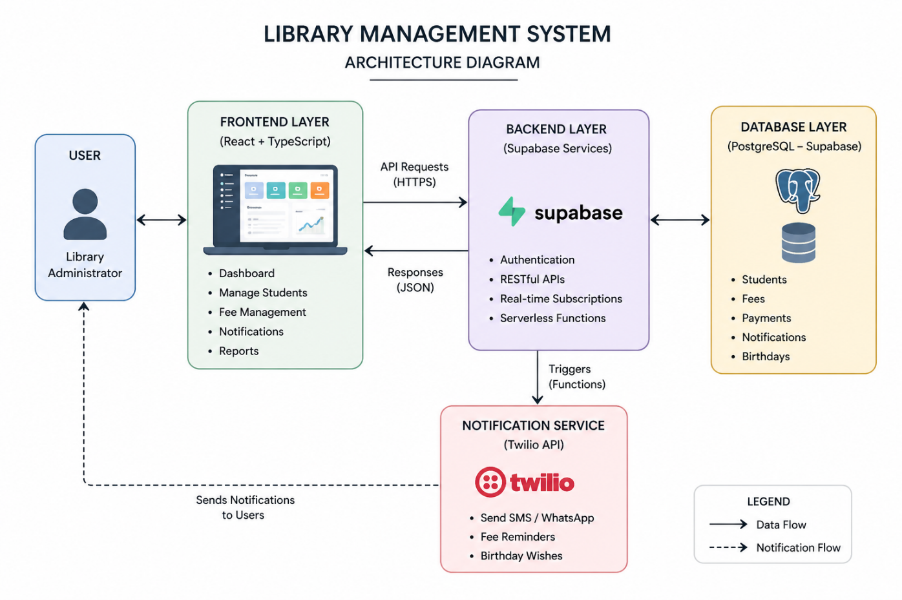
System Architecture

CHAPTER-5
ER DIAGRAM

Introduction
The Entity Relationship (ER) Diagram represents the logical structure of the database used in the Library Management System. It shows how different entities such as students, fees, and notifications are related to each other.
The ER diagram helps in understanding data flow, relationships, and database design, ensuring efficient storage and retrieval of information.

Main Entity
The system consists of the following main entities:
1. Student
- Stores student details
- Attributes:
  - Student ID (Primary Key)
  - Name
  - Phone Number
  - WhatsApp Number
  - Date of Birth
  - Registration Date
  - Status (Active/Alumni)
  - Address

2. Fees
- Stores fee-related information
- Attributes:
  - Fee ID (Primary Key)
  - Student ID (Foreign Key)
  - Amount
  - Payment Date
  - Status (Paid/Pending)

3. Notifications
- Stores notification details
- Attributes:
  - Notification ID (Primary Key)
  - Student ID (Foreign Key)
  - Message
  - Type (Fee Reminder / Birthday Wish)
  - Date

Relationships
The relationships between entities are defined as follows:
- One Student can have multiple Fee records
(One-to-Many Relationship)
- One Student can receive multiple Notifications
(One-to-Many Relationship)
Fees and Notifications are linked to Student using Student

ER Diagram

ER Diagram :
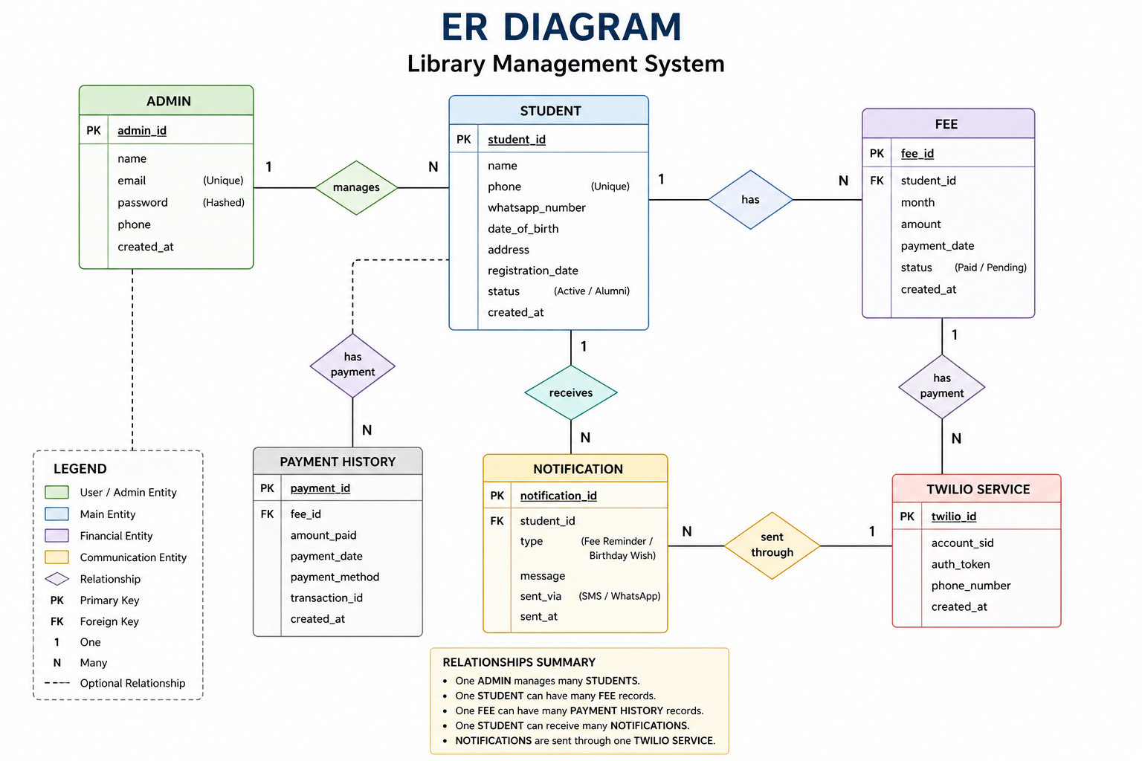

CHAPTER-6
TECH STACK USED

Frontend: React.js (with TypeScript)
The frontend of the Library Management System is developed using React.js with TypeScript. React provides a dynamic and responsive user interface, while TypeScript ensures type safety and better code maintainability.
The frontend is responsible for:

Accepting user inputs such as student details

Displaying dashboard data (students, fees, birthdays)

Managing UI components and navigation

Communicating with backend services via APIs

Advantages of React.js:
- Component-based architecture for reusable UI
- Fast rendering using Virtual DOM
- Improved user experience with dynamic updates
- Easy integration with backend APIs

Backend:Supabase (Backend as a service)
The backend of the system is handled using Supabase, which provides ready-to-use backend services without the need to build a custom server.
Main functionalities include:
    - Handling database operations (CRUD)
    - Providing REST APIs
    - Managing authentication (if used)
    - Supporting real-time data updates

Advantages of Supabase:
    - No need to build backend from scratch
    - Real-time database support
    - Secure and scalable architecture
    - Easy integration with frontend

Database: PostgreSQL (Supabase)
The system uses PostgreSQL (via Supabase) to store all application data

Data stored includes:
    - Student records
    - Fee details
    - Notifications

Advantages:
    - Structured and reliable data storage
    - Supports complex queries
    - Ensures data integrity and consistency

Tools
Various tools are used during development to improve efficiency and maintain code quality.
    - VS Code: Used for coding and debugging

    - Git & GitHub: Used for version control and code management
    - Deployment Platforms (e.g., Render/Vercel): Used to host the application
These tools help in building, testing, and deploying the project effectively.

CHAPTER-7
RESULT

Student Management
The system successfully manages student records in a structured and efficient manner. It allows the administrator to add, update, and maintain detailed student information.
    - Stores complete student details
    - Supports easy data modification
    - Maintains active and alumni status
    - Reduces manual record-keeping errors

Fee Management
The system effectively tracks student fee payments and identifies pending dues.
    - Tracks monthly fee status
    - Automatically identifies defaulters
    - Displays total collection and pending fees
    - Improves fee management efficiency

Notification System (Twilio)
The integration of Twilio enables automated communication with students.
    - Sends SMS/WhatsApp fee reminders
    - Notifies students about pending payments
    - Sends birthday wishes to students and alumni
    - Reduces manual communication effort

Dashboard & Insights
An interactive dashboard provides a clear overview of important data.
    - Displays active students, pending fees, and collections
    - Shows upcoming birthdays
    - Provides quick insights for decision-making
    - Improves overall monitoring of the system

    - Enables easy retrieval of previous results

Data Management
The system ensures efficient handling and storage of data.
• Stores data securely using Supabase
• Provides real-time updates
• Ensures data accuracy and consistency
• Enables easy data retrieval
  - Screenshots of the Project
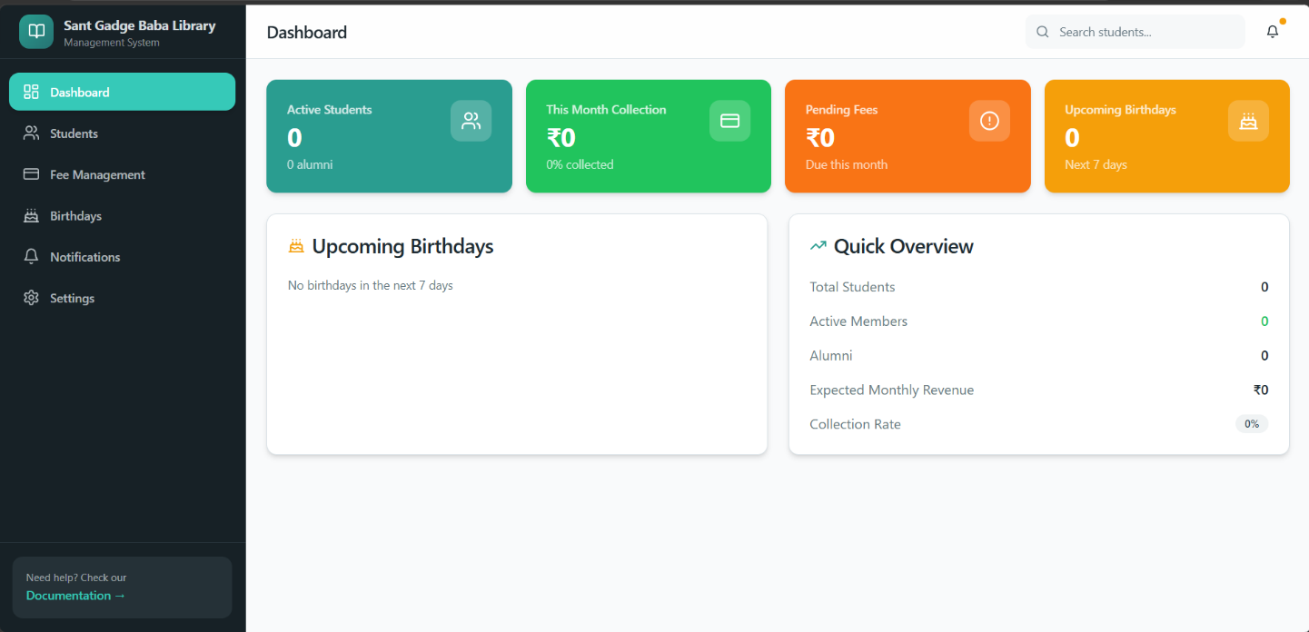

HOME PAGE

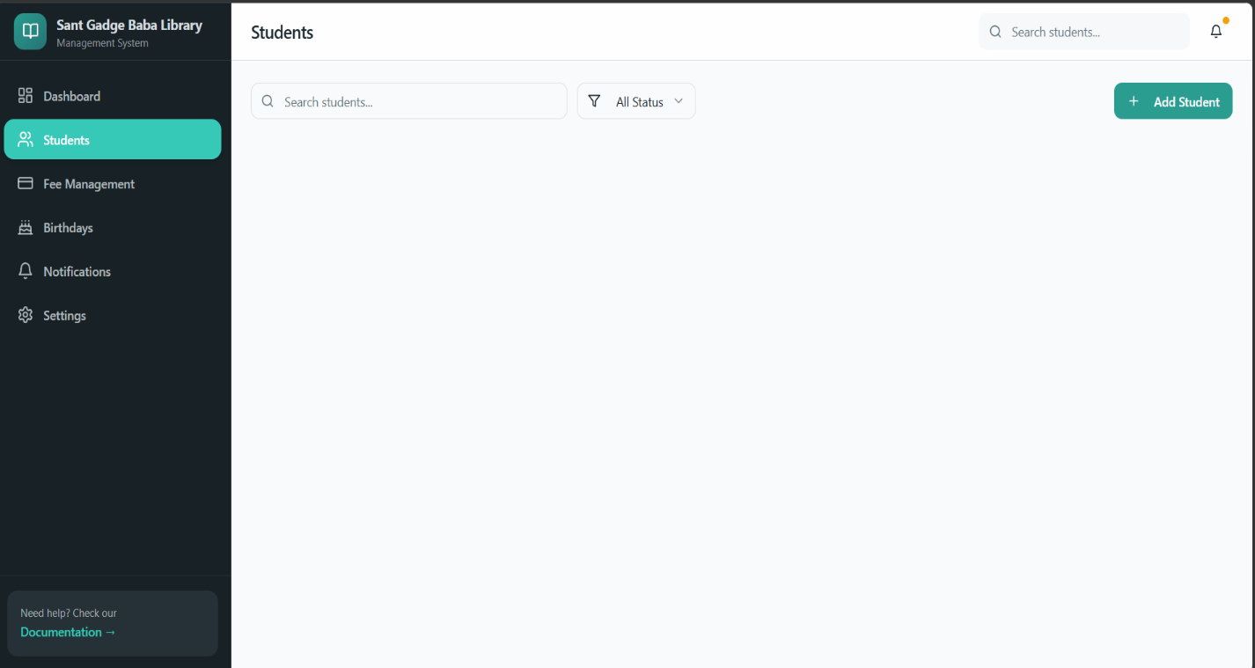

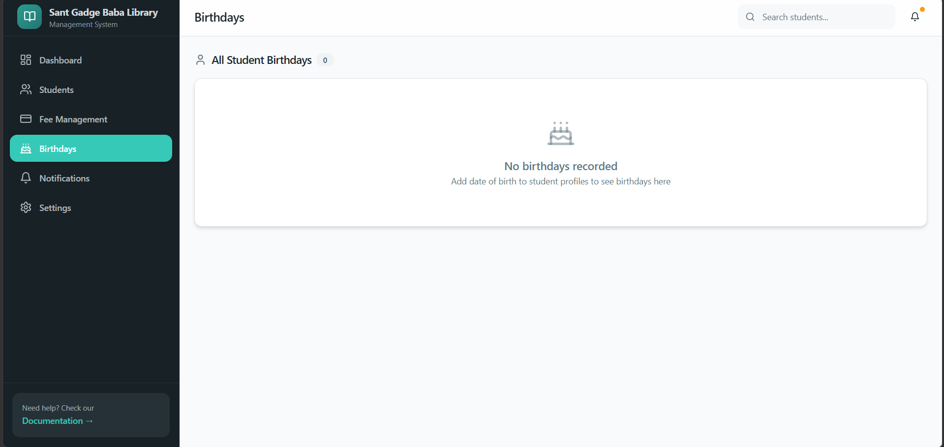

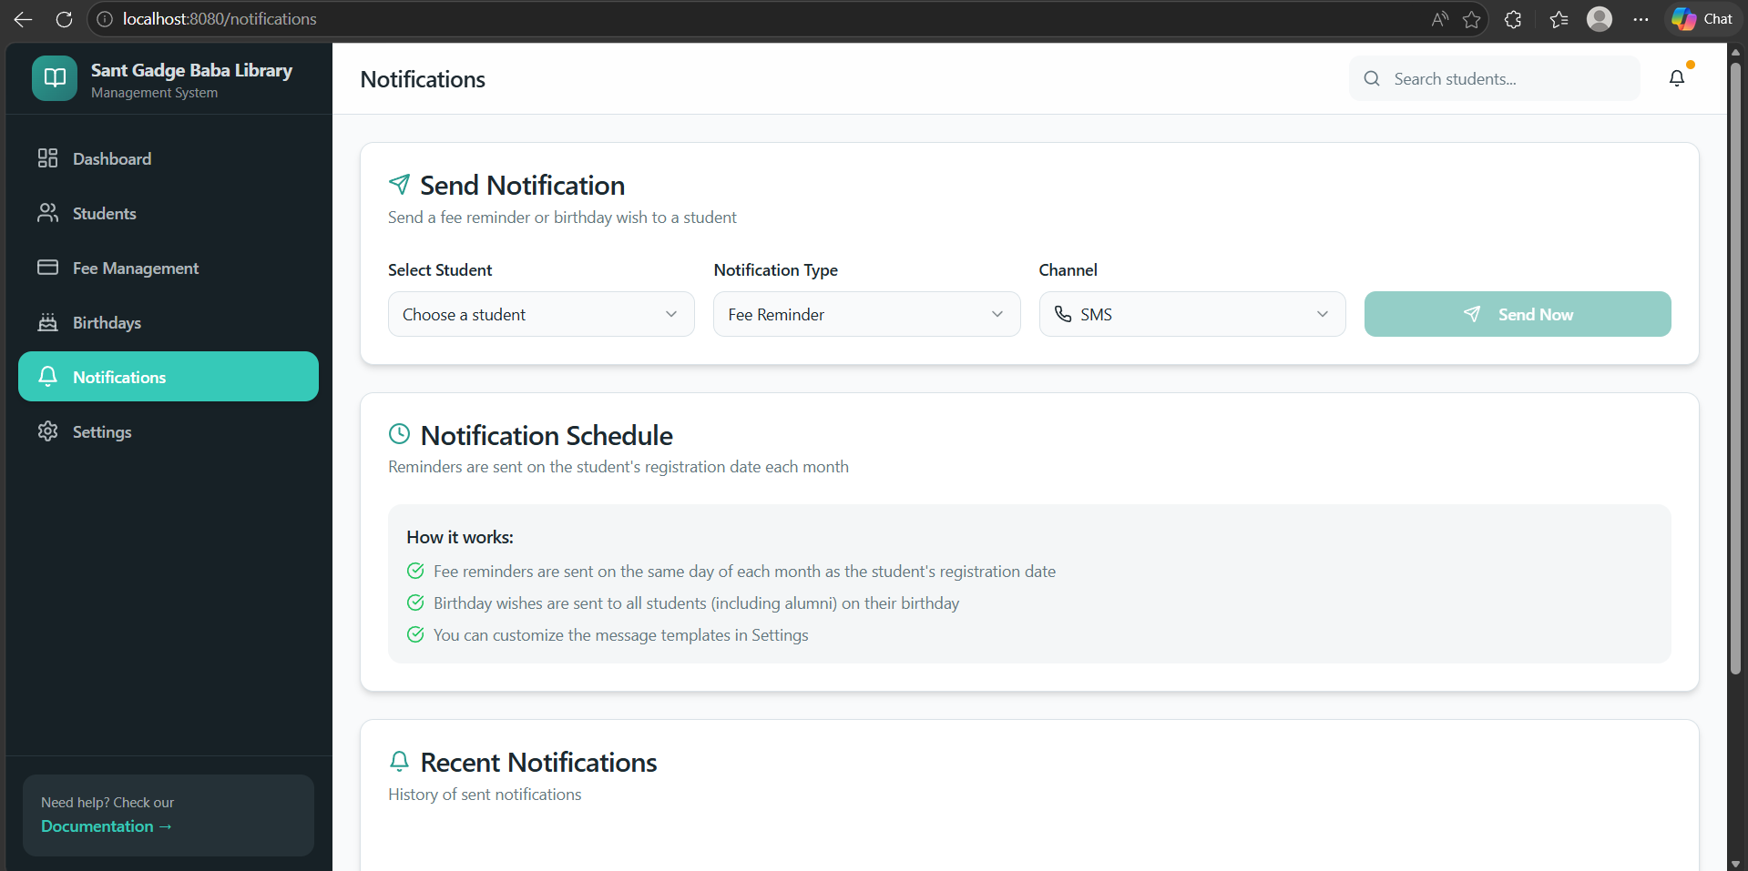

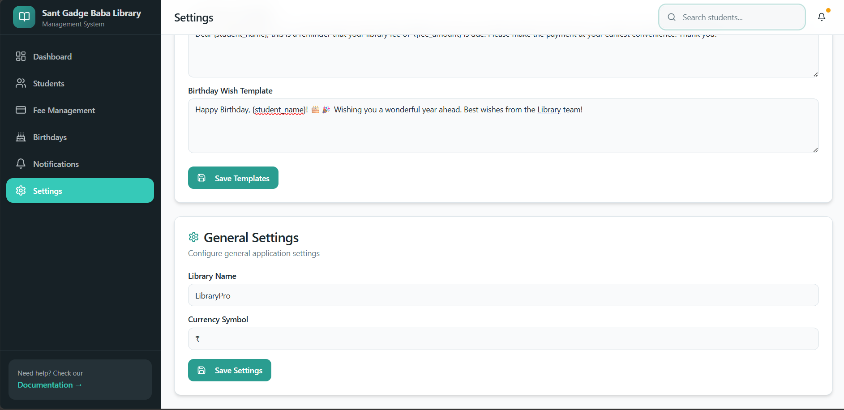
Code Screenshots:
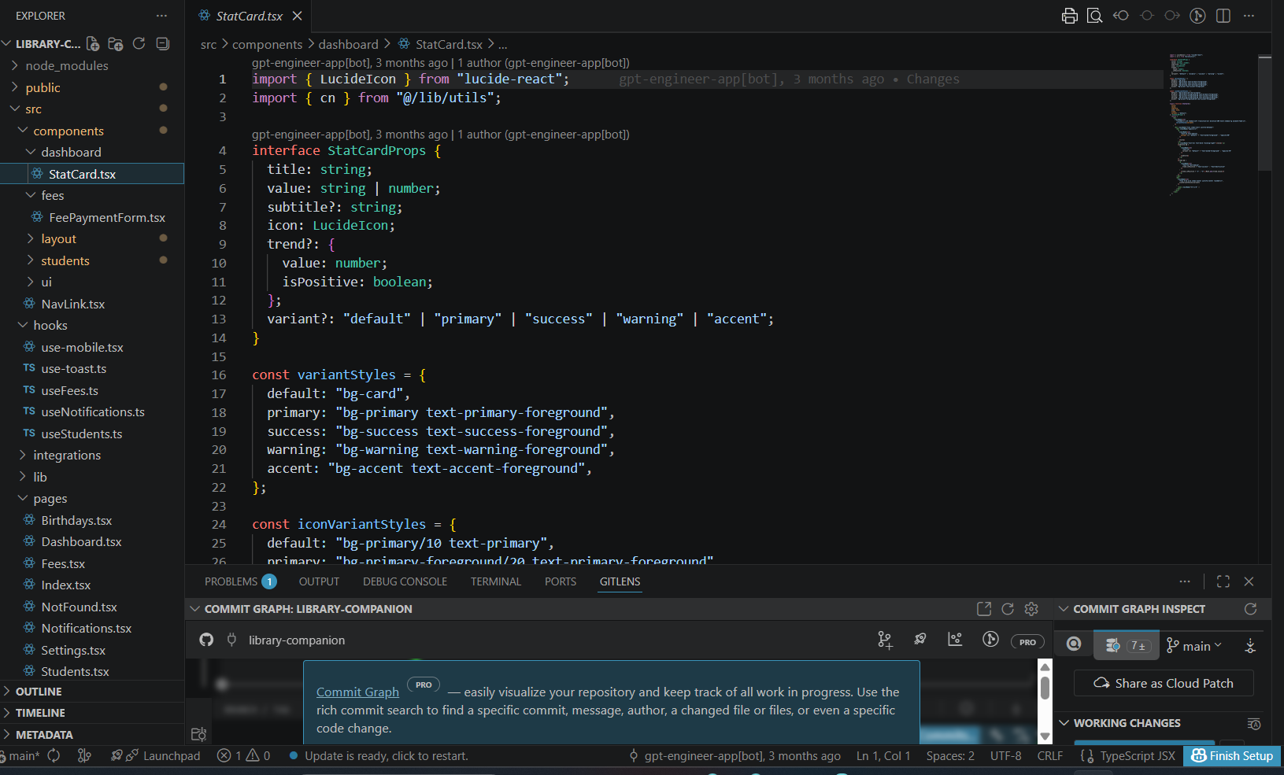
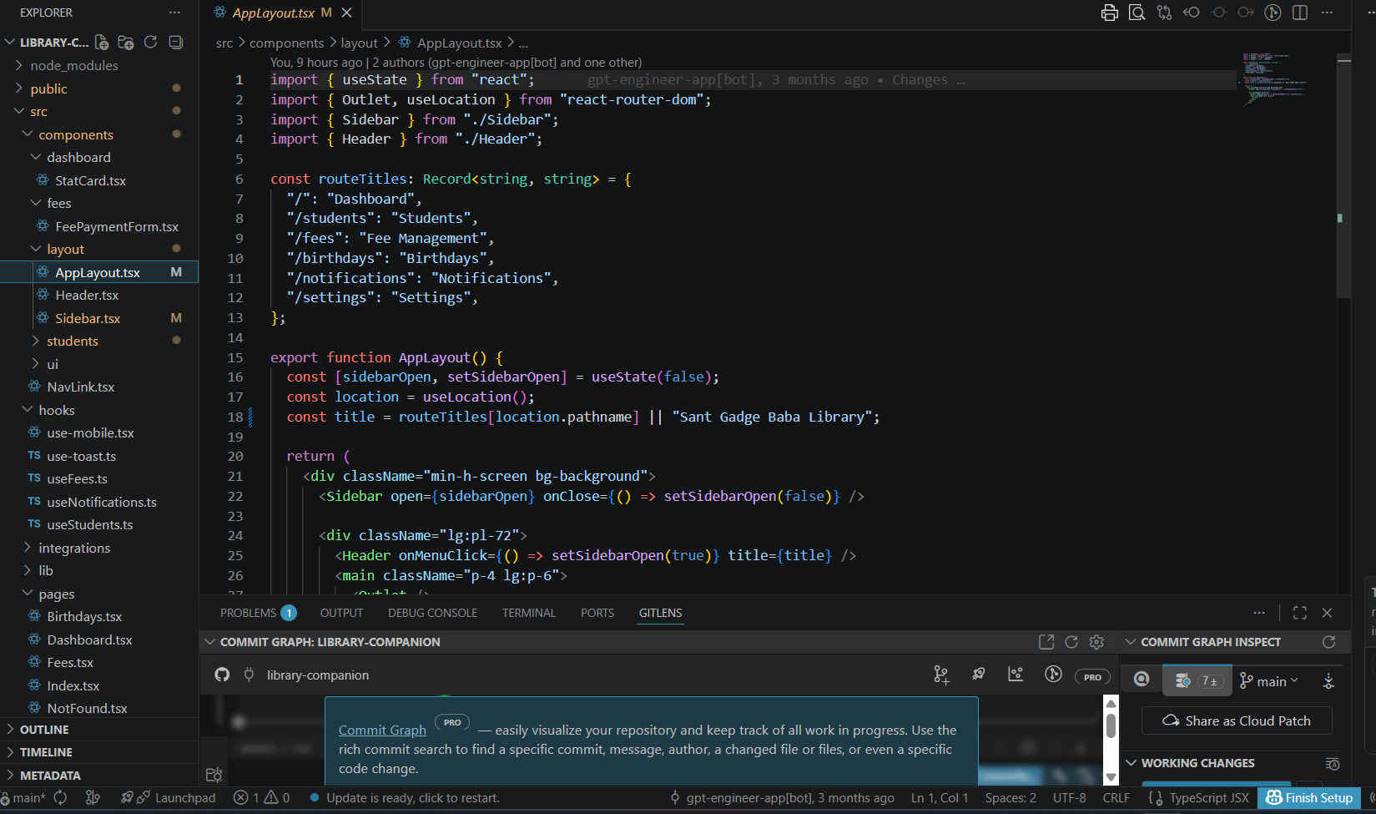

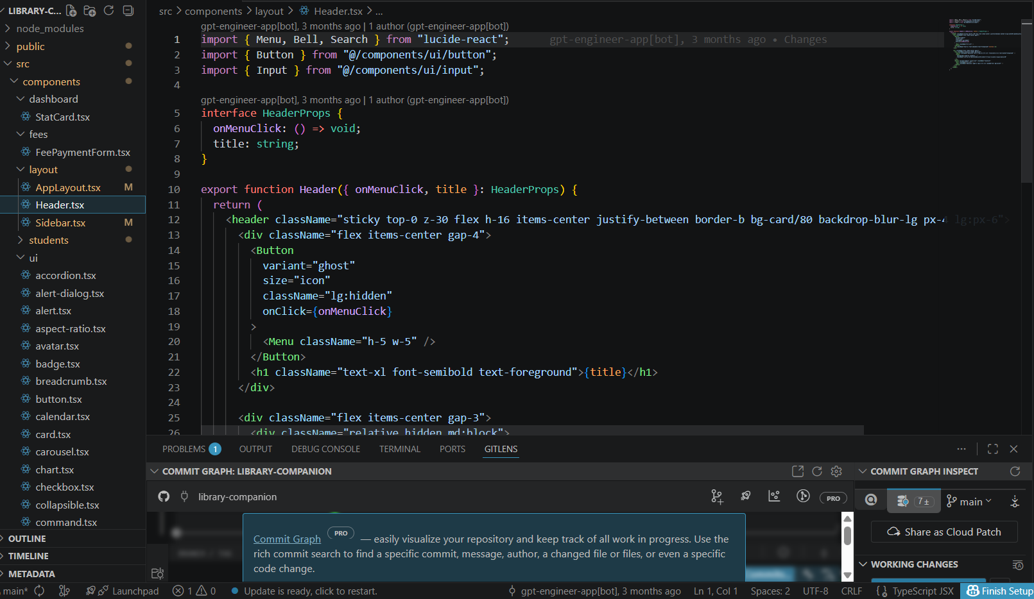
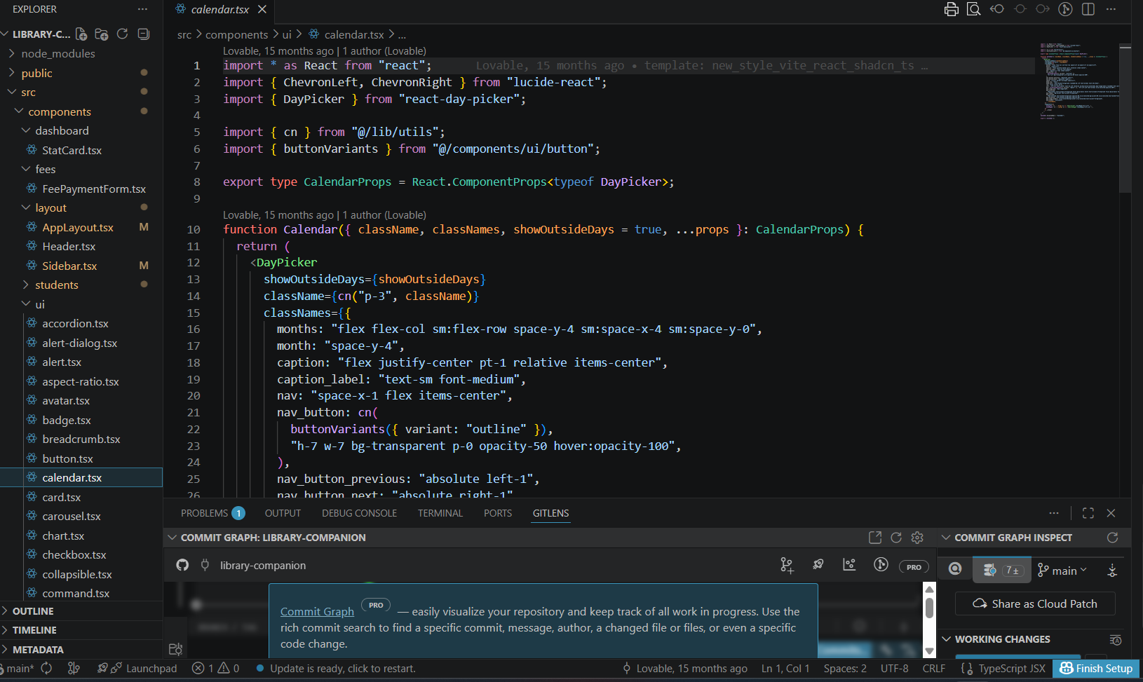

Conclusion:
The Library Management System successfully provides a modern and automated solution for managing student records, fee tracking, and communication within a library. The system eliminates the limitations of traditional manual methods by introducing a centralized and efficient digital platform.
By integrating real-time data handling using Supabase, the system ensures accurate and up-to-date information, allowing administrators to manage student details and fee records with ease. The automated fee tracking feature helps identify pending payments quickly, improving financial management and reducing manual effort.
The integration of the Twilio API enhances the system by enabling automated SMS and WhatsApp notifications. Features such as fee reminders and birthday wishes improve communication and strengthen engagement with both current students and alumni.
The interactive dashboard provides clear insights into key metrics such as active students, monthly collections, pending fees, and upcoming birthdays. This helps in better decision-making and efficient monitoring of library operations.
Overall, the project demonstrates the practical implementation of modern web technologies, automation, and third-party integrations to solve real-world problems. The system is scalable, user-friendly, and reliable, making it a valuable solution for effective library management as well as a strong learning experience in full-stack development.

FUTURE SCOPE
The Library Management System can be further enhanced with additional features and improvements to increase its functionality and usability.
    - Mobile app (Android/iOS) for easy access
    - Online fee payment integration (UPI/cards)
    - Advanced reports and analytics dashboard
    - Multi-library support system
    - Role-based user access (admin/staff)
    - Email notifications along with SMS/WhatsApp
    - QR/biometric attendance system
    - Cloud deployment for scalability

